OUTPUT
TASK 1 :CLEAN THE DATA(LOWERCASE)
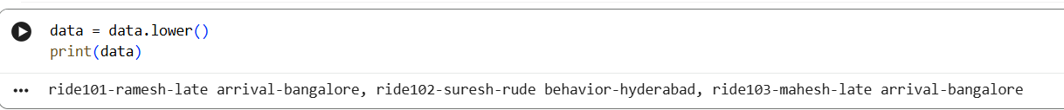
TASK 2: COUNT TOTAL COMPLAINTS RECORDS
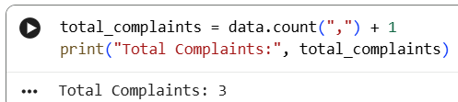
TASK 3: COUNT LATE ARRIVAL ISSUES
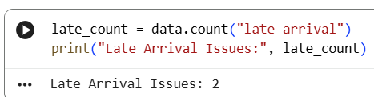
TASK 4 : COUNT COMPLAINTS FROM BANGALORE
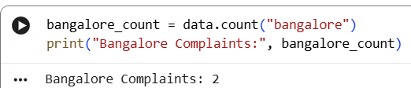
TASK 5 : EXTRACT FIRST DRIVER NAME
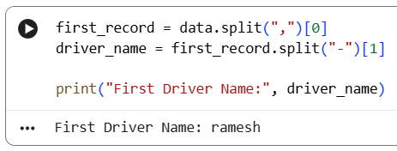
TASK 6 : REPLACE ISSUE NAMES
